**Assignment 2**

1. Git Setup<https://confluence.atlassian.com/bitbucket/set-up-git-744723531.html>

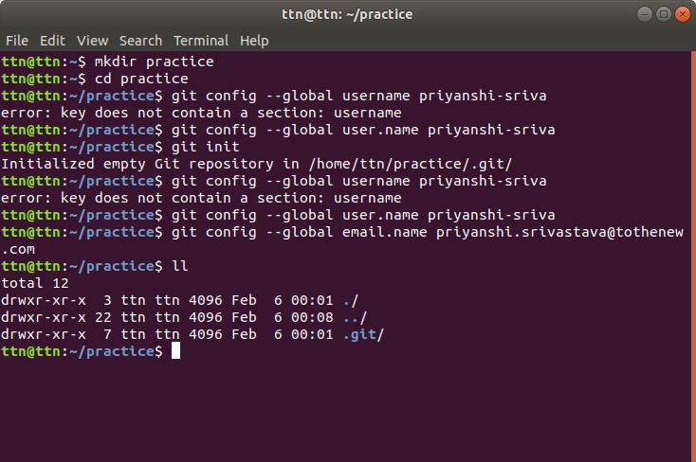

2. Initialize a Git Repository.

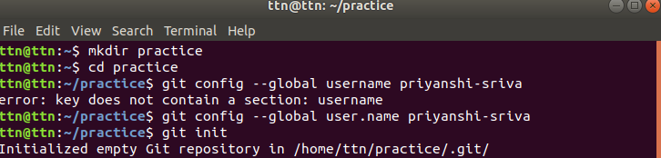

3. Add files to the repository

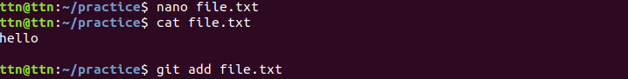

4. Unstage 1 file.

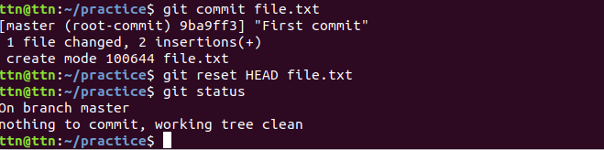

5. Commit the file.

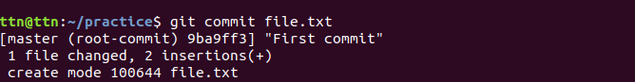

6. Add a remote.

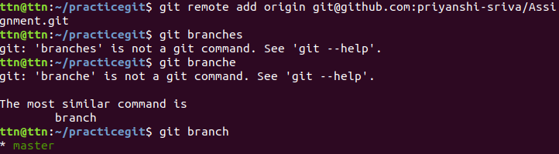

7. Undo changes to a particular file.

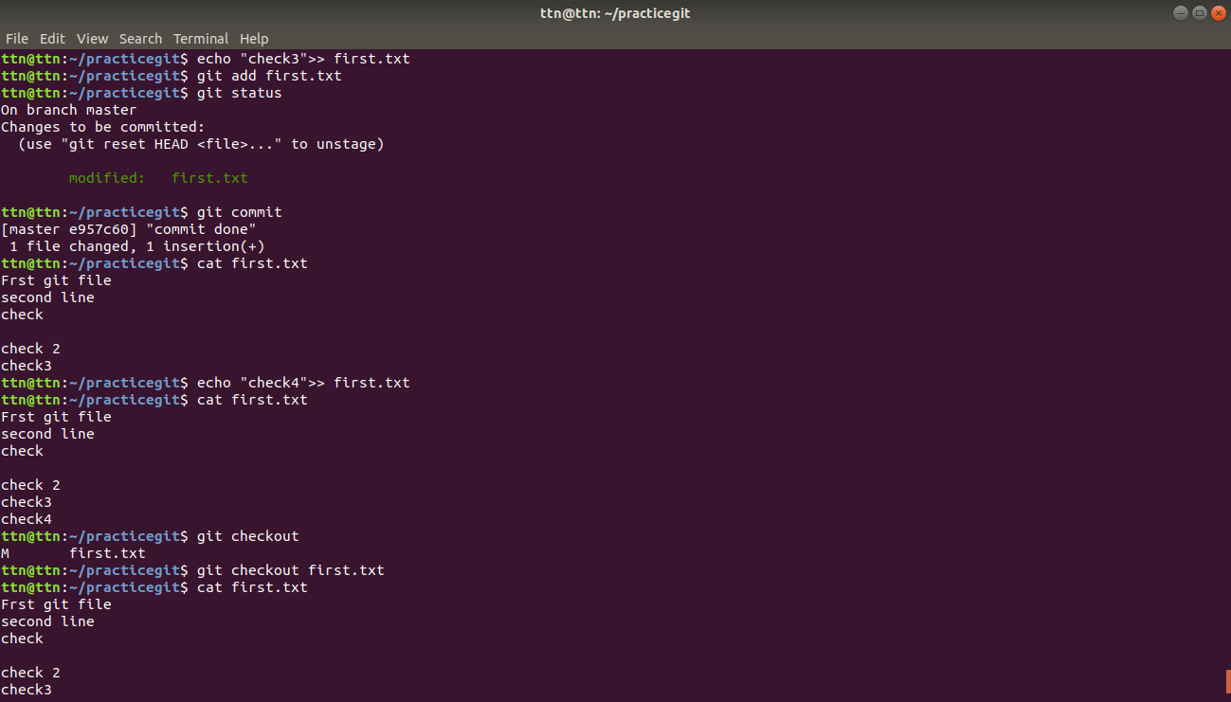

8. Push changes to Github.

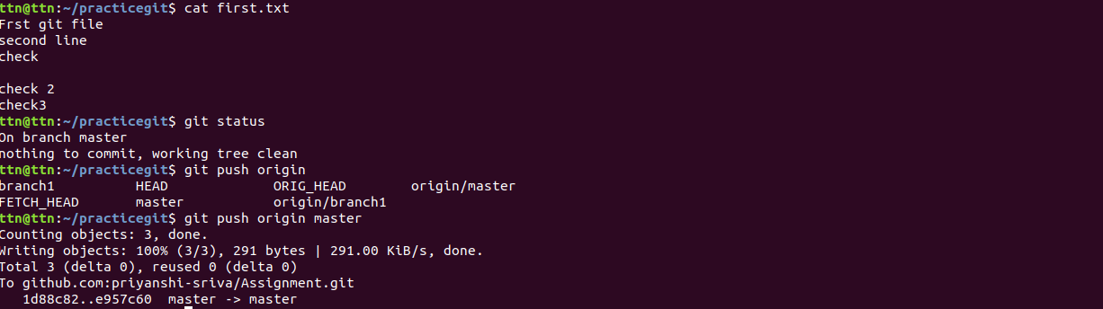

9. Clone the repository.

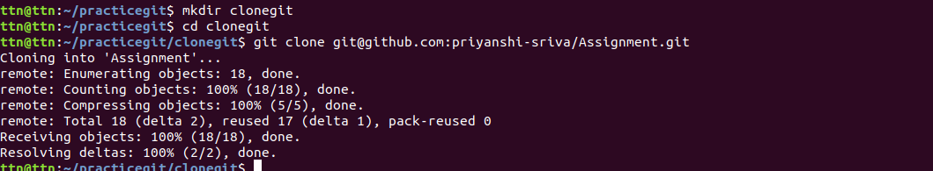

10. Add changes to one of the copies and pull the changes in the other.

nano exercise.txt

git commit exercise.txt

git push origin master

git checkout branch2

git pull origin master

11. Check differences between a file and its staged version

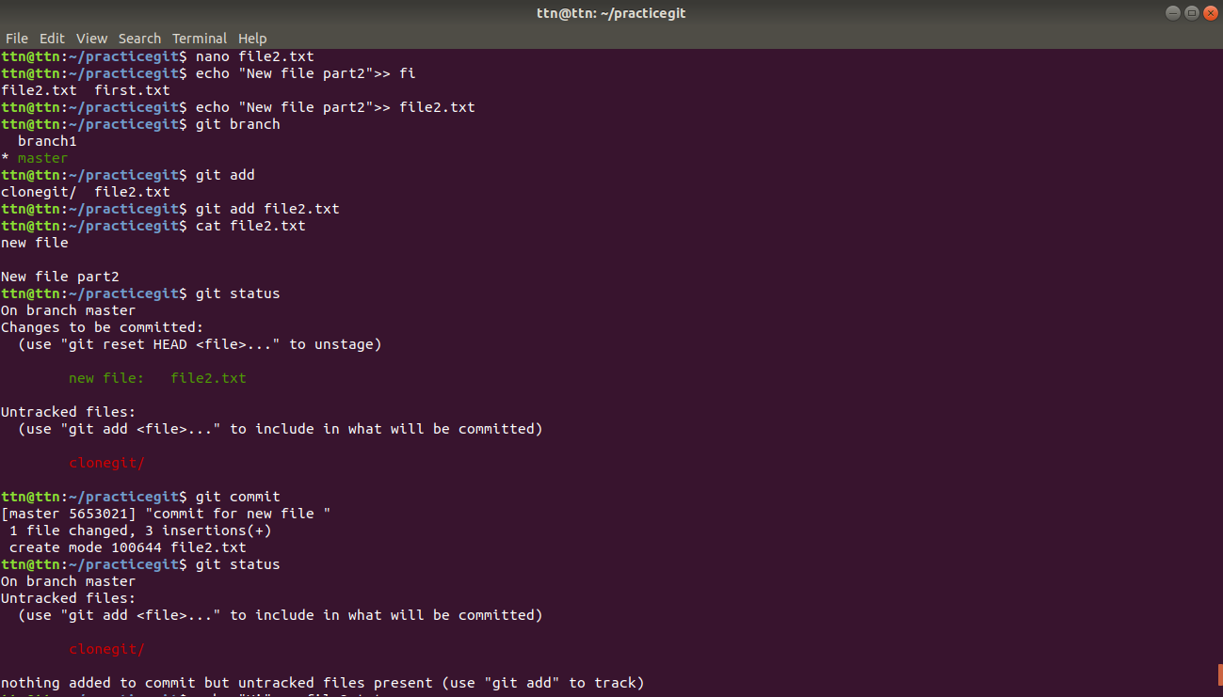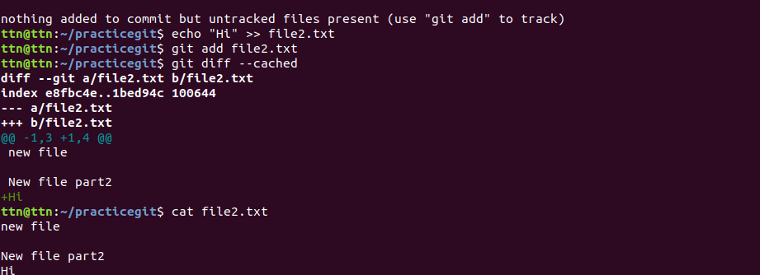

12. Ignore a few files to be checked in



13. Create a new branch.

git checkout -b nameofnewBranch

18. Add the following code to your .bashrc file : color_prompt="yes"  
 parse_git_branch() {  
 git branch 2> /dev/null | sed -e '/^[^*]/d' -e 's/* \(.*\)/(\1)/'  
 }  
 if [ "$color_prompt" = yes ]; then  
 PS1='\u@\h\[\033[00m\]:\[\033[01;34m\]\W\[\033[01;31m\] $(parse_git_branch)\[\033[00m\]\$ '  
 else  
 PS1='\u@\h:\W $(parse_git_branch)\$ '  
 fi  
 unset color_prompt force_color_promp